700120 Lab Book

Contents

Week 1 – Lab A 2

Week 2 – Lab B 10

Week 3 – Lab C 19

Week 4 – Lab D 27

Week 5 – Lab E 34

Week 6 – Lab F 49

# Week 1 – Lab A

Date: 27th Sep 2022

## Q1. Hello World

### Question:

Locate the Solution Explorer within Visual Studio and select the HelloWorld project. Right click on this project and select Build. This should compile and link the project. Now run the HelloWorld program.

Change between Debug and Release mode. Compile again and rerun the program.

### Solution:

#include <iostream>

int main(int, char**) {

std::cout << "Hello World" << std::endl;

return 0;

}

### Test data:

n/a

### Sample output:

n/a

### Reflection:

This is programming 101

### Metadata:

Hello World

### Further information:

What are purpose are the parameters in main?

## Q2. Console Window

### Question:

Delay the termination of the program by adding the following two lines to the end of your code:

int keypress;

std::cin >> keypress;

### Solution:

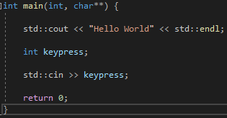

### Test data:

n/a

### Sample output:

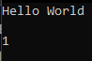

### Reflection:

This just stops the program from terminating as soon as the program what finished running.

### Metadata:

Delay termination

### Further information:

Is this something that’s only really done for educational purposes?

## Q3. Includes

### Question:

Remove “#include <iostream>” then compile, what is the effect>

### Solution:

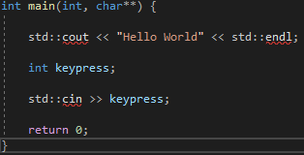

### Test data:

n/a

### Sample output:

n/a

### Reflection:

cin and cout can’t be used because the program doesn’t have access to the iostream

### Metadata:

includes

### Further information:

n/a

## Q4. Namespace

### Question:

Add “using namespace std;” and remove all “std::”

### Solution:

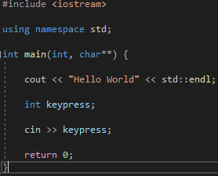

### Test data:

n/a

### Sample output:

n/a

### Reflection:

I thought that visual studio would make you get rid of the “std::” to compile if you as using the std namespace but apparently not

### Metadata:

Namespace std

### Further information:

n/a

## Q5. Create a new project

### Question:

Create a new Visual C++ Empty project called “Temperature”

### Solution:

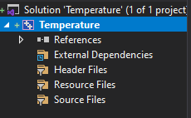

### Test data:

n/a

### Sample output:

n/a

### Reflection:

Very straight-forward, nothing to comment on

### Metadata:

New project

### Further information:

n/a

## Q6. Temperature

### Question:

Create a new cpp file within the temperature project and write a program to input a Fahrenheit measurement, convert it and output a Celsius value.

### Solution:

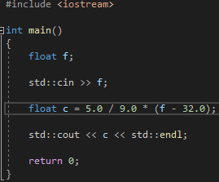

### Test data:

Input: 32 output: 0

Input: 33 output: 0.555556

### Sample output:





### Reflection:

Need to remember that is I want a float answer then the numbers in the calculation should be floats as well.

### Metadata:

Conversion

### Further information:

n/a

## Q7. Auto, const and casting

### Question:

Now rewrite your temperature example using the auto keyword, constants and explicit casting

### Solution:

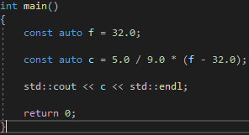

### Test data:

n/a

### Sample output:



### Reflection:

I would say that this takes more thought to read than the previous implementation but this defiantly uses less lines of code, but also has less functionality.

### Metadata:

keywords

### Further information:

What would be some use cases for the auto keyword?

## Q8. Static assert

### Question:

Create a new project call sizeOf. Select a different architecture (e.g. x86 or x64) to see if you can make the assert fail.

### Solution:



### Test data:

Switch between x86 and x64 architecture

### Sample output:

n/a

### Reflection:

The assert doesn’t work on the x64 architecture. I’m guessing we will find out why when the lectures start.

### Metadata:

asserts

### Further information:

n/a

# Week 2 – Lab B

Date: 04/10/2022

## Q1. Timing

### Question:

Run the given application on your pc and examine the results. Try increasing the loop limit and architecture.

### Solution:



### Test data:

Loop limit = 20 Loop limit = 40

### Sample output:

Loop limit: 20 Architecture: x64 Loop limit: 20 Architecture: x86

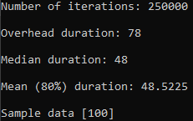 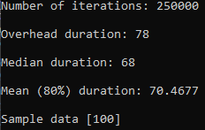

Loop limit: 40 Architecture: x64 Loop limit: 40 Architecture: x86

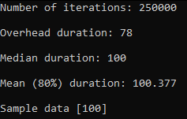 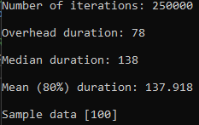

### Reflection:

There is an increase in median duration when on a x86 architecture.

When increasing the loop limit the mean duration is a little over double the time. The only explanation I can think of is since there is double the amount of loops then there is more work to do and more opportunity of the branching to be wrong.

### Metadata:

Timings

### Further information:

Remember that timing in debug is pointless

## Q2. Timing own code

### Question:

Replace the payload with some of your own code

### Solution:

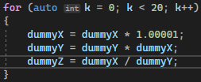

### Test data:

Loop limit = 20 Loop limit = 40

### Sample output:

Target: 20 Architecture: x64 Target: 20 Architecture: x86

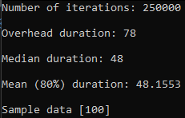 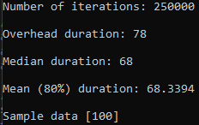

Target: 40 Architecture: x64 Target: 40 Architecture: x86

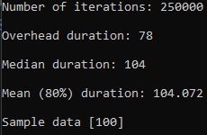 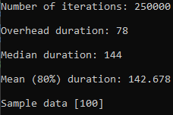

### Reflection:

My timing code didn’t seem to have much different times from the given example even though more operations are happening in my for loop.

### Metadata:

Own code

### Further information:

n/a

## Q3. Conditionals

### Question:

Add each of the conditional statements in turn to the payload to try and identify any performance differences.

### Solution:

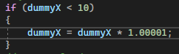

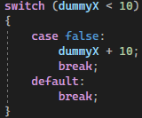



### Test data:

n/a

### Sample output:

If x64 – If x86 –

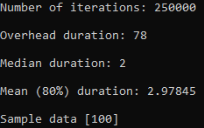 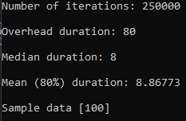

Switch x64 – Switch x86 –

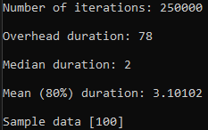 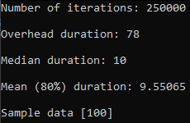

?: x64 – ?: x86 –

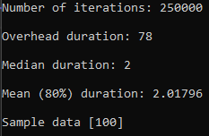 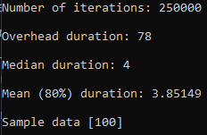

### Reflection:

All of the different conditionals seem pretty similar, they all do worse on x86 architecture as expected. It seems the ?: does a little bit better than if on a x86 architecture though

### Metadata:

Conditions

### Further information:

n/a

## Q4. Branch prediction

### Question:

Add a piece of code to the payload that demonstrates when branch prediction is working well and when branch prediction is failing

### Solution:

Fail Pass

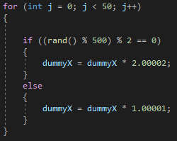 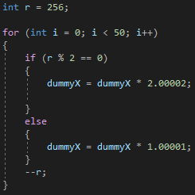

### Test data:

n/a

### Sample output:

Fail x64 x86

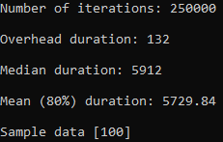 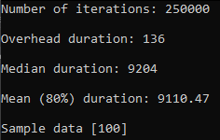

Pass x64 x86

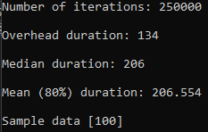 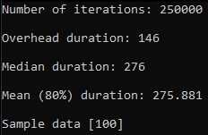

### Reflection:

I am not 100% sure that I have done this right but the “fail” example defiantly does worse in terms for speed. The branch predictor should only have a 50-50 chance on predicting right in the fail example because the conditions are reliant on a random number.

### Metadata:

Failure

### Further information:

Check with Warren to see if I have done this correctly

## Q5. Exiting a nested loop

### Question:

Add each option for exiting a nested loop to the payload section of the timing code and determine if there are any performance differences between each approach

1. Two conditions in each conditional section of the loops. One for the loop control and the other as the exit condition
2. An additional if statement immediately following the inner loop to catch and propagate a break statement
3. A goto statement in the inner loop
4. A lambda function

### Solution:

1.

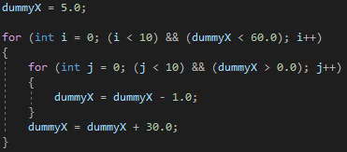

2.

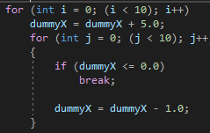

3.

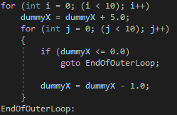

4.

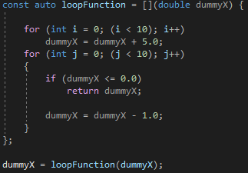

### Test data:

n/a

### Sample output:

1. x64 x86

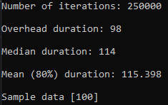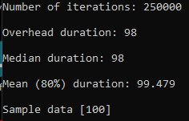

2. x64 x86  
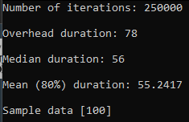 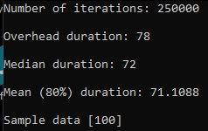

3. x64 x86

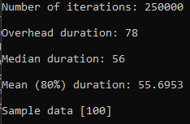 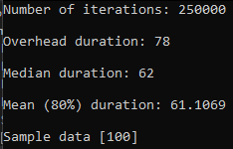

4. x64 x86

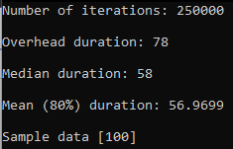 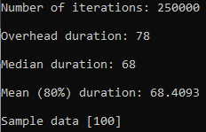

### Reflection:

I am not sure I have implemented all of these correctly but based on my results all of the methods of exiting a loop are fairly similar in speed except for method 1 (Two conditions in each conditional section of the loops. One for the loop control and the other as the exit condition). When running the tests in x86 architecture they all run slower than the x64 as expected.

### Metadata:

Nested

### Further information:

They are supposed to be all pretty equal method 1 is wrong because of the ovehead

## Q6. Range based loop

### Question:

Compare the performance of standard loops and range based loops

### Solution:

Standard Range-Based

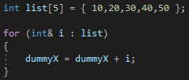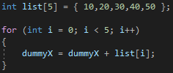

### Test data:

n/a

### Sample output:

Standard x64 x86

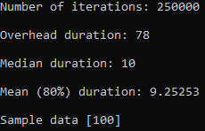 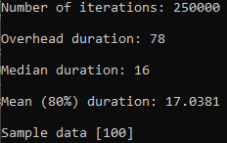

Range-Based x64 x86

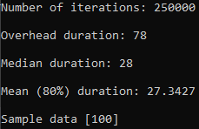 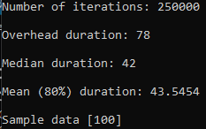

### Reflection:

Ranged-based is significantly slower both in x64 and x86. I was expecting it to be quicker. Maybe I’ve implemented it wrong

### Metadata:

Range-Based

### Further information:

Are my results as expected? If so why is it so much slower? **They are actually pretty equal in speed**

## Q7. Architecture

### Question:

Run the previous experiments in both x64 and x86 architechture

### Solution:

n/a

### Test data:

n/a

### Sample output:

n/a

### Reflection:

I’ve done this as part of each question and commented on the architecture differences in each

### Metadata:

X86

### Further information:

n/a

# Week 3 – Lab C

Date:

## Q1. Debugging

### Question:

Determine what the problem is with the program and suggest a solution to make the program execute correctly.

### Solution:

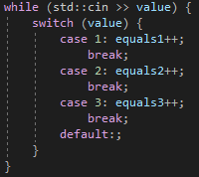

### Test data:

 

### Sample output:

 

### Reflection:

The problem was that the switch didn’t have a break at the end of each case causing the code to fall through. So, if case 1 was triggered so would case 2 and 3. The fix is simply adding in the breaks for each case

### Metadata:

Switch error

### Further information:

n/a

## Q2. Bitwise

### Question:

Write a program to read four separate 32-bit integers (red, green, blue, and alpha) and encode them into a single 32-bit value. Output this 32-bit value. Verify that the results are correct by taking the 32-bit value and extracting and outputting the separate integers.

### Solution:

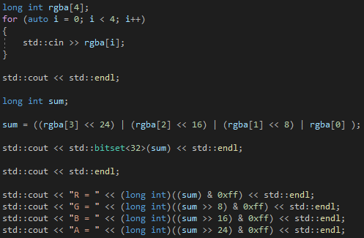

### Test data:

 

### Sample output:

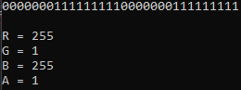 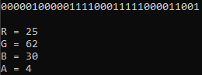

### Reflection:

This took a while and I had to get quite a bit of help but I think I understand bitwise a bit better now. I should still do some more research into bitwise stuff though.

### Metadata:

Bitwise encoding

### Further information:

n/a

## Q3. Parsing

### Question:

Modify the program to make the loop structures more efficient and easier to maintain. Time the code to determine if you have made to code more efficient.

### Solution:

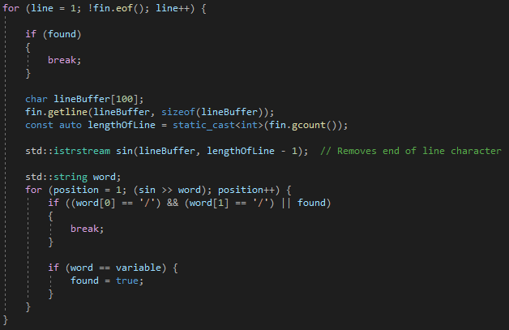

### Test data:

Release x64 Original Mine

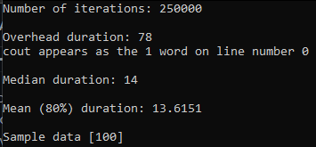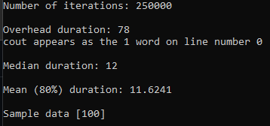

### Sample output:



### Reflection:

My solution is ever so slightly faster however when I was doing the timing the times for the original seemed to vary wildly so I’m not 100% sure if it is more efficient. In terms of maintainability, I’d say the 2 solutions are equal and I’m not sure how you could improve maintainability.

### Metadata:

Parsing improvement

### Further information:

n/a

## Q4.

### Question:

Modify the quadratic program to:

1. Handle equal or imaginary roots
2. Output the roots to only 3 decimal places

Time the new code and try to improve efficiency

### Solution:

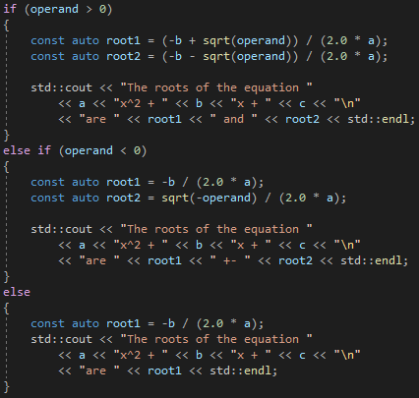



### Test data:

  

### Sample output:







Release x64

Real & Diff

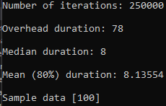 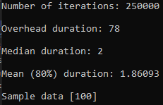 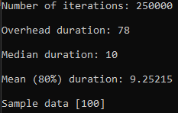

Imaginary

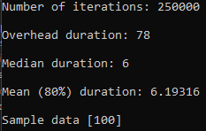 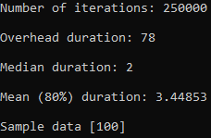 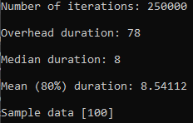

Real Same

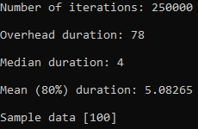 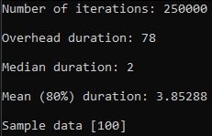 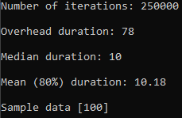

### Reflection:

This was really hard to do purely because I don’t remember anything about quadratic equations. When I came to the try to improve efficiency part I couldn’t think of any way to get any improvement. I need to use a conditional for the program and the other types of conditionals aren’t appropriate. I think I remember seeing Warren do the precision differently in a lecture but I couldn’t find it or remember it, I think % was used somehow.

### Metadata:

Quadratic equations

### Further information:

I think I saw Warren do precision another way so I need to ask him how he does it

I noticed that the overhead massively increases if my laptop is unplugged. It goes from ~80 when plugged in to ~200 when unplugged.

## Q5. Assembly

### Question:

Open and step through the assembly code from the parsing exercise. Do this in debug mode.

### Solution:

### 

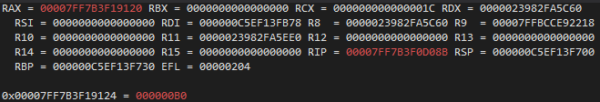

### Test data:

n/a

### Sample output:

n/a

### Reflection:

I’ve gone through the assembly and I understand what is happening for the most part but I think that’s only due to the fact that I know what’s supposed to be happening in the code, if I was just given the assembly code with no other context I don’t think I’d be able to tell you what the related piece of code was doing.

After going through the assembly code, I noticed there were a few instructions that I didn’t recognise so I’ve found out what they mean and put them below:

nop = No operation

inc = Increment (+1)

movsx/movsxd = Move with Sign-Extension

movzx = Move with Zero-Extend

test = Preforms a bitwise and

dec = Decrement (-1)

xor = Perform a bitwise exclusive or

### Metadata:

Parsing Assembly

### Further information:



Why is there a d on the end of the R9 and R8 register?

## Q6. Optimizer

### Question:

In release mode disassemble the code you wrote for the quadratic exercise in the timing code.

### Solution:

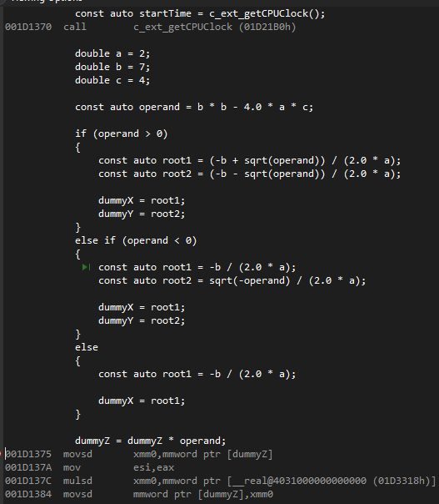

### Test data:

n/a

### Sample output:

n/a

### Reflection:

The optimiser seems to have completely thrown out my code and seems to be figuring out the answers in the following section ready to print later:

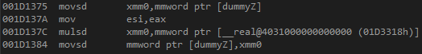

I don’t really understand what’s happening or why. I though since the roots and operand are need to alter the dummy values before they get printed that the optimiser would leave my code alone.

mulsd = Multiply Scalar Double-Precision Floating-Point Value

cmovg =  conditional move if greater check the state of ZF, SF AND OF. If ZF=0 AND SF=OF then condition is satisfied, otherwise it will be skipped.

cmp = subtracts one operand from the other for comparing whether the operands are equal or not

### Metadata:

Optimiser

### Further information:

Is this what was expected or have I done something wrong

# Week 4 – Lab D

Date: 25/10/2022

## Q1. Object Parser

### Question:

Complete the object parser code. It must be able to copy data to an output file and identify the object with the largest size.

### Solution:

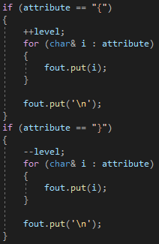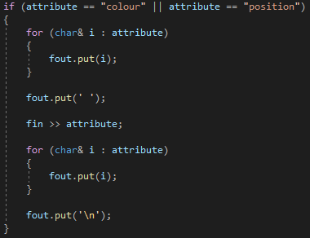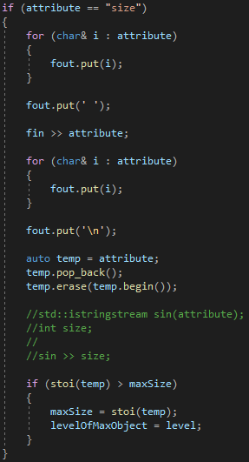

### Test data:

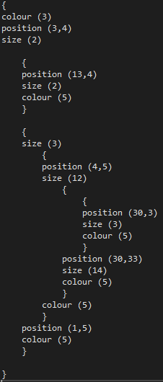

### Sample output:

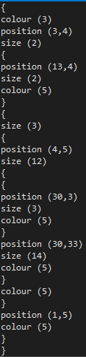

### Reflection:

This wasn’t too difficult the most difficult part was converting a size string into an int. Warren suggested using istringstream but I don’t think I was using it right because it always gave a size of 0.

Note: I know I could have just used streaming operators for writing but I wanted to practice using range-based for loops.

### Metadata:

Parsing Objects

### Further information:

What am I doing wrong with the istringstream?

## Q2. Object Parser (Recursive)

### Question:

Create a recursive solution to the previous task. No loop structures allowed

### Solution:

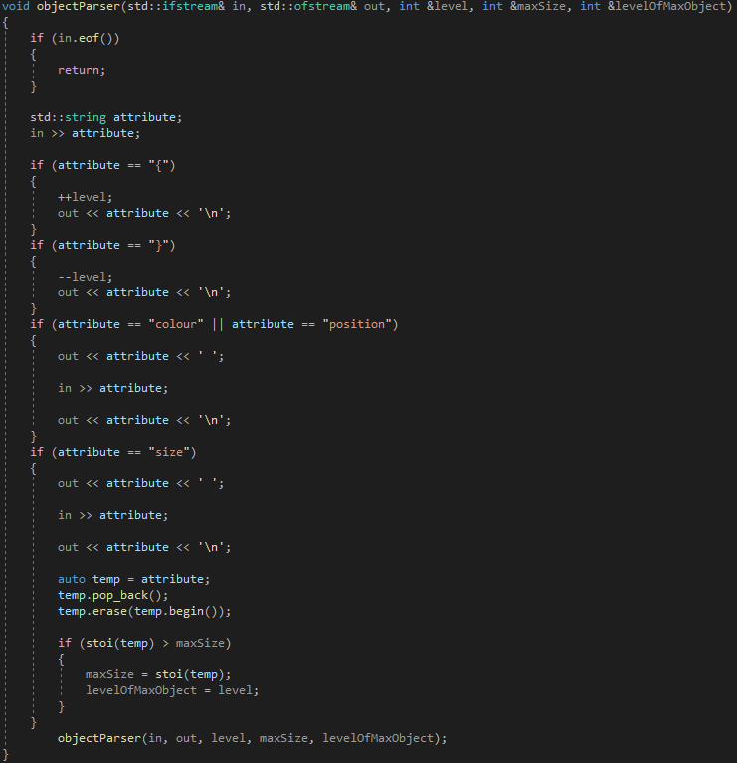

### Test data:

Same as previous task

### Sample output:

Same as previous task

### Reflection:

This was pretty straight forward, I probably have too many parameters so it’s a bit messy and has a lot of room for errors to be made.

### Metadata:

Recursion

### Further information:

n/a

## Q3. Object Parser Comparison

### Question:

Write some timing code a use it to compare the speed of object parsing with loop structures and with recursion.

### Solution:



### Test data:

n/a

### Sample output:

|  |  |
| --- | --- |
| **Loop structures Release x64** | **Recursion Release x64** |
|  |  |
|  |  |
|  |  |
|  |  |
|  |  |
| *Average Time = 106560 nanoseconds* | *Average Time = 112300 nanoseconds* |

### Reflection:

The timings seem pretty similar loop structures do come out to be a bit faster in my timings but this is probably just luck of the draw since I just took 5 random timings for each solution. I probably should have looped through multiple iterations and gotten the average like that.

### Metadata:

Comparison

### Further information:

For the loop structures I changed to way things a written to the output.txt so they matched across both solutions

## Q4. Tuples

### Question:

Select one of your object parsers and wrap the code within a new function. This new function has a single parameter, the file name, and returns a tuple consisting of the size of the largest object and the level of the largest object

### Solution:

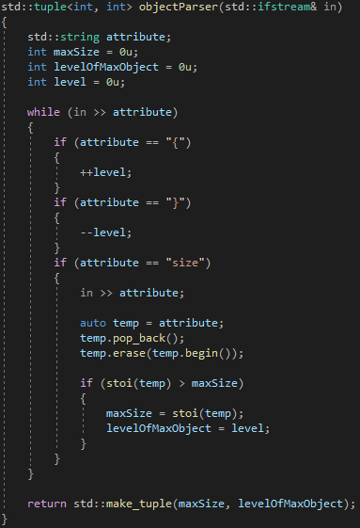

### Test data:

Sample.txt

### Sample output:



### Reflection:

This was pretty simply to do, I cut out most of the code since we aren’t writing to the out put file for this question.

### Metadata:

Tuple

### Further information:

n/a

## Q5. Span and Arrays

### Question:

1. Create a version of the code that uses the array template, which wraps a vanilla C array within a C++11 template.
2. Create a version of this function that uses the C++20 span to pass the array to the function. span removes the need for the second parameter

### Solution:

1.

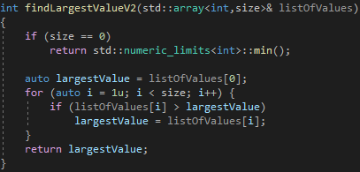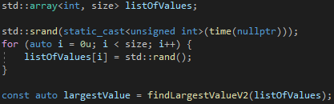

2.

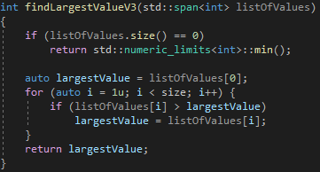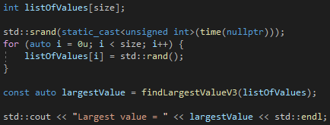

### Test data:

n/a

### Sample output:

1.



2.



### Reflection:

Fairly straight forward there isn’t much to comment on. Span defiantly seems like it would be the way I would want to do it if it’s possible to.

### Metadata:

Arrays

### Further information:

n/a

# Week 5 – Lab E

Date: 01/11/2022

## Q1. Basic vectors

### Question:

1. Add cross product and dot product methods to the given ‘Vector3d’ class.

2. Write new methods to overload the basic binary operators.

3. Overload the ‘-‘ unary operator so that it inverts the vector.

4. Use timing code to analyse the performance of each implementation of adding 2 vectors.

### Solution:

1.

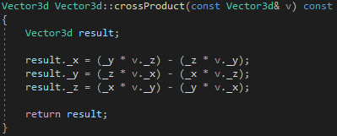

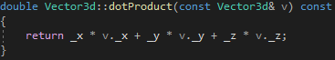

2.

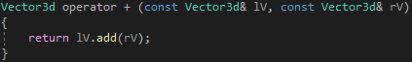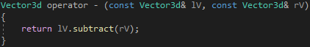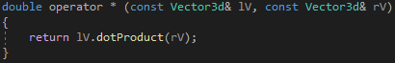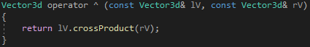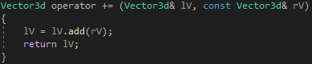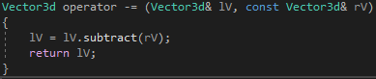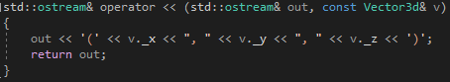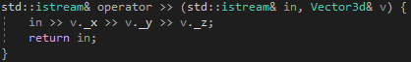

3.

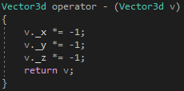

4.

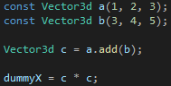 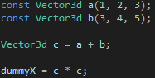 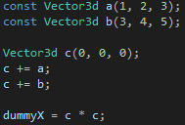

### Test data:



### Sample output:

1.

 = 

 = 

2.

 = 

 = 

 = 

 = 

 = 

 = 

 = 

### =

3.

 = 

4.

Release x64

.add()

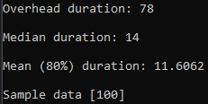

+

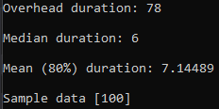

+=

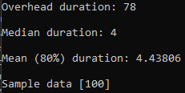

### Reflection:

This was a pretty easy task to do. In terms of the timings for the addition it is as I would have expected for the most part with operators being faster weirdly enough though += seems to be faster than +.

### Metadata:

### Further information:

Some methods are inline to remove the associated overhead which will improve execution time

Why exactly are operators faster than a method? The operators are calling the method anyway

Why is += faster the +?

## Q2. Commutativity

### Question:

Implement both a standard method and overload the * operator to multiply a vector by a single double. Also implement the multiplication of a single double by a vector.

### Solution:

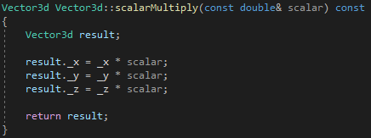

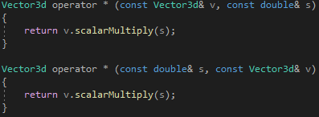

### Test data:

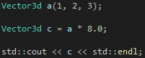 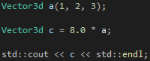

### Sample output:



### Reflection:

This was pretty straight forward there isn’t a lot to really comment on

### Metadata:

Scalar multiply

### Further information:

n/a

## Q3. Matrices

### Question:

Add the functionality to do the following:

1. Addition
2. Subtraction
3. Multiplication
4. Streaming in and out
5. Inverse
6. Transpose

### Solution:

1.

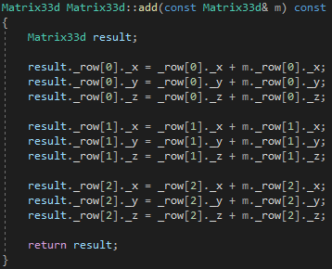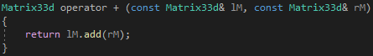

2.

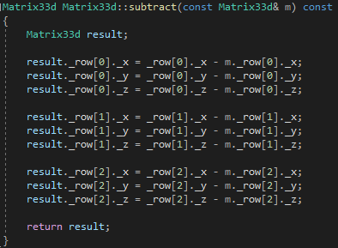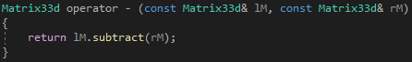

3.

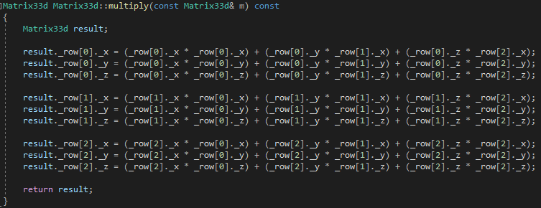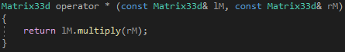

4.

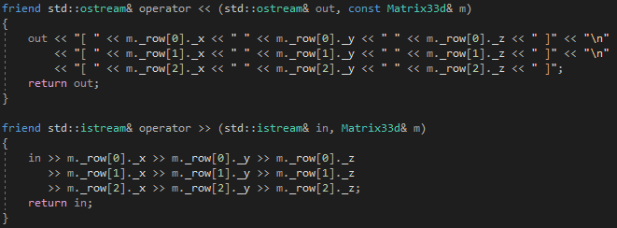

5.

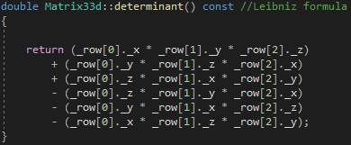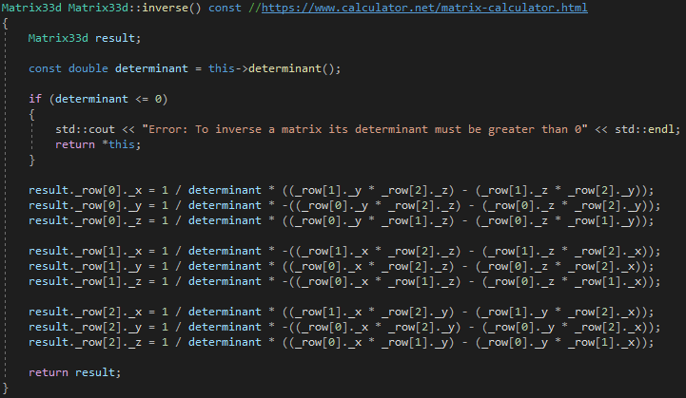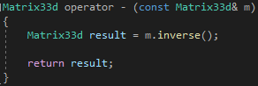

6.

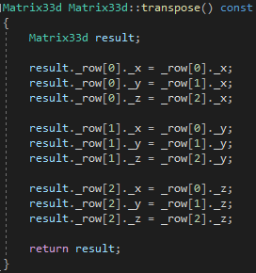

### Test data:

 

### Sample output:

 = 

 = 

 = 

 = 

 = 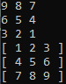

 = 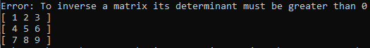

 = 

 = 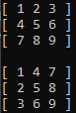

### Reflection:

This was a complicated task purely because of some of the maths involved especially inversing. I struggled to find an appropriate operator to overload for transposing. Is it sometimes better to use a method call over an operator? Operators are quicker but in the case of the transpose it can be less clear what is going on.

### Metadata:

Matrix maths

### Further information:

Why does  work but  doesn’t? I thought . and -> were the same, is it because is a method call within a class

## Q4. Vector and Matrix Multiplication

### Question:

Expand your Matrix33d class to be able to multiple a Vector3d object by a Matrix33d object

### Solution:

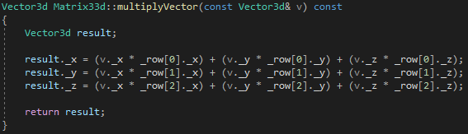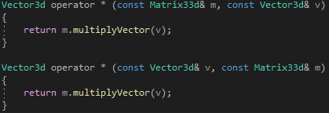

### Test data:

 

### Sample output:

 = 

 = 

### Reflection:

This was very simple assuming I’ve understood the task correctly. It seems too simple so I have a feeling I’ve misunderstood something

### Metadata:

Vector * Matrix

### Further information:

n/a

## Q5. Internal data structures

### Question:

implement the Matrix33d using a different data format and assess the performance using the timing code from earlier labs

### Solution:

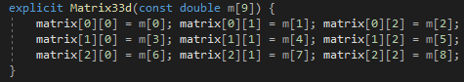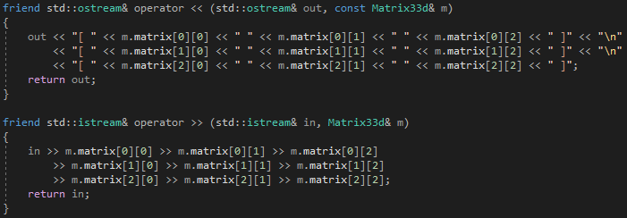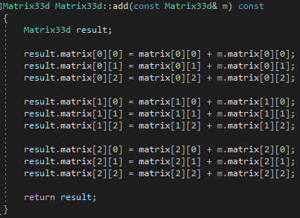

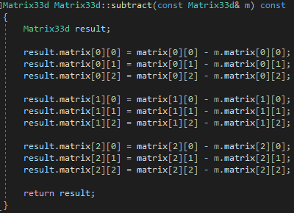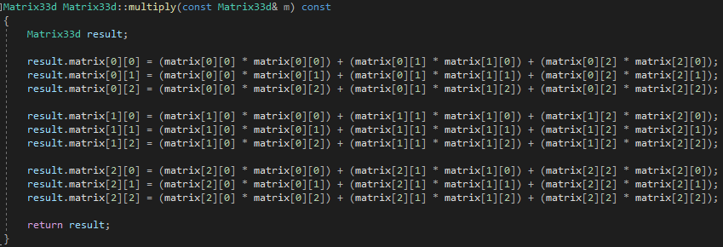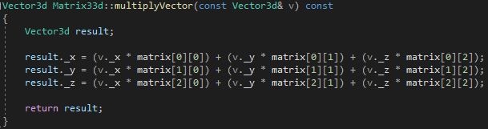

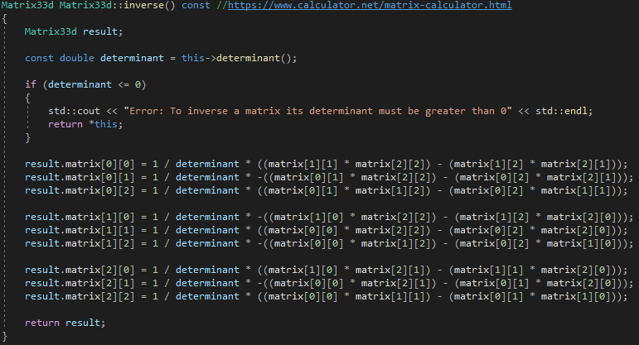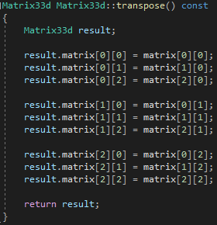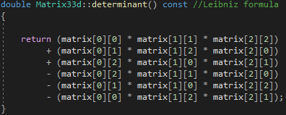

### Test data:

n/a

### Sample output:

Array of Vector3d

|  |  |
| --- | --- |
| Addition |  |
| Subtraction |  |
| Multiply Matrices |  |

Multidimensional array of doubles

|  |  |
| --- | --- |
| Addition |  |
| Subtraction |  |
| Multiply Matrices |  |

### Reflection:

I decided that the best data structure to implement would be a multidimensional array of doubles, this is essentially the same as the original implementation which was and array of ‘Vector3d’ object. I think the multidimensional array is a lot easier to read and understand though. When looking at timings it seems multidimensional is quicker but the timing was pretty inconsistent so I’m not sure if it is

### Metadata:

Matrix data structures

### Further information:

n/a

# Week 6 – Lab F

Date: 08/11/2022

### Q1. Big strings

#### Question:

Expand the “BigString” class to contain at least the following functionality:

1. Constructors
2. Destructor
3. Assignment operator
4. Stream in and out
5. Index operator

#### Solution:

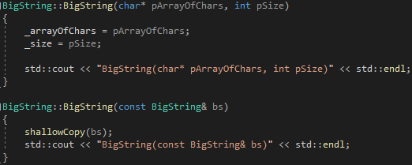

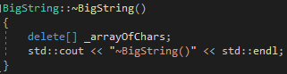

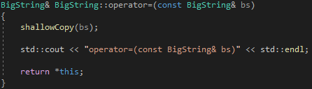

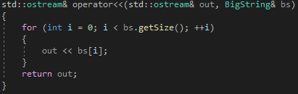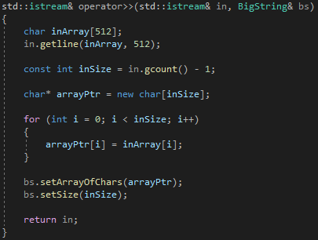



#### Test data:



#### Sample output:

 = 

 = 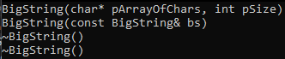

 = 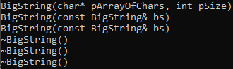

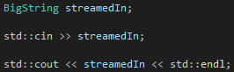 = 

#### Reflection:

I don’t think I really understand destructors that well, I was having a problem with mine but I eventually fixed it. I’m unsure when to use shallow copies or deep copies, deep copies seem superior

#### Metadata:

Gang of three

#### Further information:

When would you want to use shallow copies instead of deep copies?

### Q2. Test harness

#### Question:

Create code to test all the functionality within BigString. Include at least the following tests:

1. Pass BigString to a function, by value
2. Pass BigString to a function, by reference
3. Return BigString from a function, by value
4. Return BigString from a function, by reference
5. Assign one BigString object to another

Also check for possible memory leaks

#### Solution:

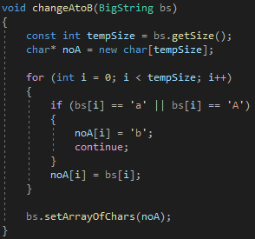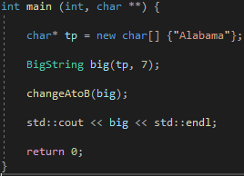

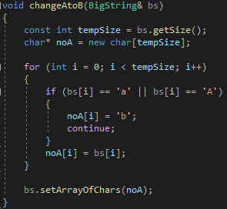

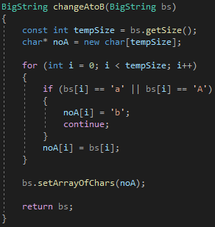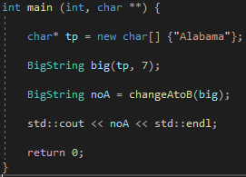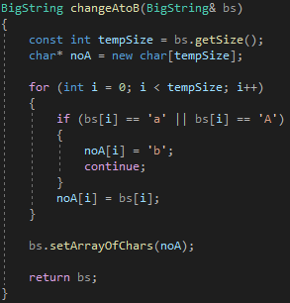

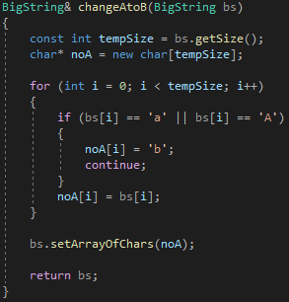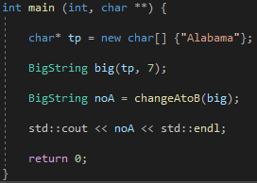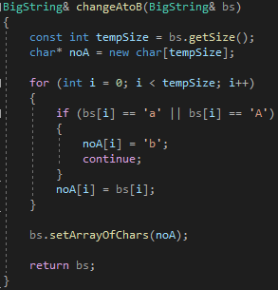

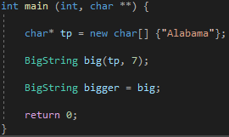

#### Test data:



#### Sample output:

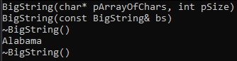



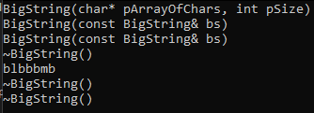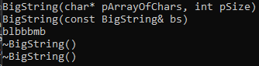

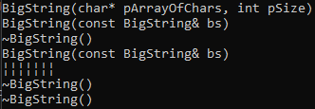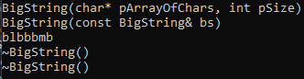

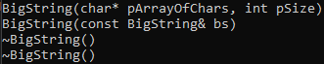

Memory Leak Detecting

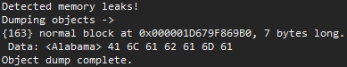

#### Reflection:

I’m not sure what part 5 is really expecting, isn’t it just the same as what I have done for the assignment operator testing? Is it to make us think about shallow and deep copies?

I also struggle to understand detecting memory leeks, I think I understand what a memory leek is (solution 1 of part 4 is an example of a memory leek) but the detecting part is confusing to me, **I was doing it right I was just looking in the wrong place**.

#### Metadata:

Testing

#### Further information:

Can you go through memory leek testing briefly?

### Q3. Optimisation

#### Question:

Now that you have a clear picture of which BigString functions are being called; are there any situations where you think you can improve the performance of your code?

#### Solution:

n/a

#### Test data:

n/a

#### Sample output:

n/a

#### Reflection:

The only optimisation I can really think of is maybe using uniform initialization for the default constructor, I’m not sure if this actually has an effect on performance though. We could potentially overload the new and delete operators as well but I don’t understand this enough to be able to say if it would improve performance

#### Metadata:

Optimise

#### Further information:

Are there ways to optimise

## Week 7 – Lab G

Date: 15/11/2022

### Q1. Benchmarks

#### Question:

Produce a set of reliable, reproducible and effective benchmarks.

#### Solution:

Vector3d Benchmark



Matrix33d Benchmark



#### Test data:

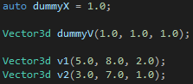

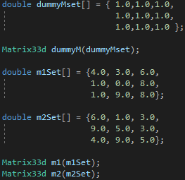

#### Sample output:

Vector3d Benchmark Results

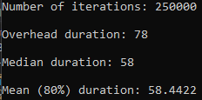

Matrix33d Benchmark Results

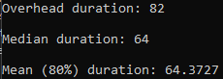

#### Reflection:

There isn’t much to comment on with this task. The Vector3d class took a bit more to get the timing up to a suitable level for a benchmark I assume that’s just because the matrix maths is more expensive.

#### Metadata:

Benchmarks

#### Further information:

n/a

### Q2. SIMD

#### Question:

Convert your vector and matrix classes to use the SIMD instructions. Time your results. How did they compare to your original implementation?

#### Solution:

Vector SIMD

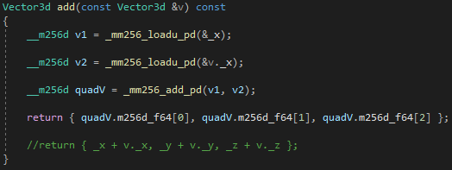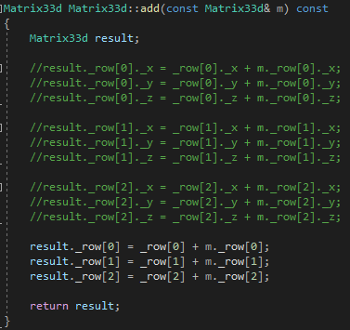

#### Test data:

#### Sample output:

Vector SIMD Timing

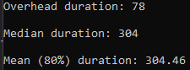

Matrix SIMD Timing

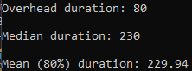

#### Reflection:

I must be doing something wrong because instead of getting quicker each got 4-6 times slower. Maybe I’m not targeting the right CPU architecture? Although I did double check that I was.

#### Metadata:

SIMD Intrinsic

#### Further information:

What am I doing wrong? Is it that I’m not targeting the correct architecture or something?

### Q3. Profilers

#### Question:

Profile the Raytracer, using both a sampling and instrumented profiler.

#### Solution:

Sampling

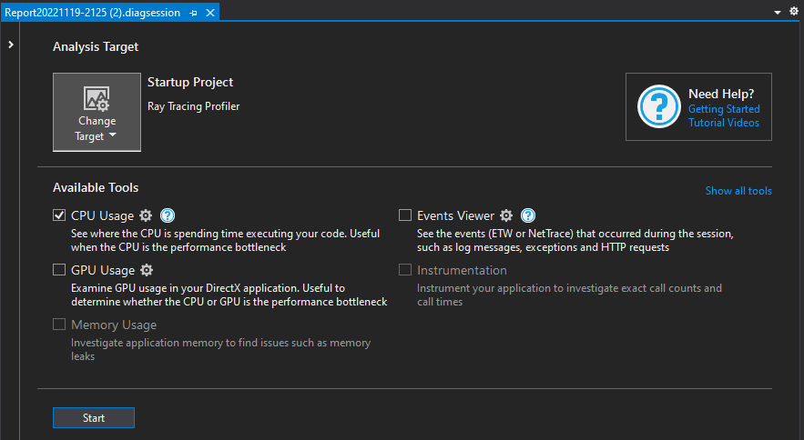

Instrumented

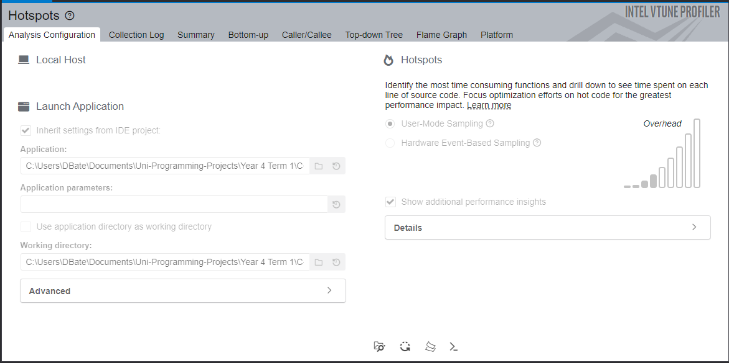

#### Test data:

n/a

#### Sample output:

Sampling

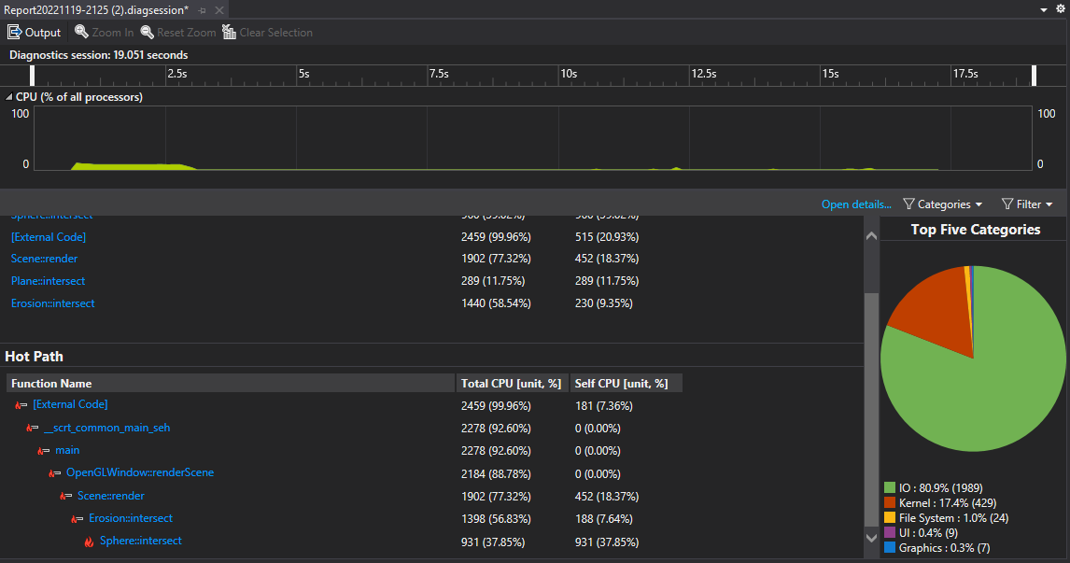

Instrumented

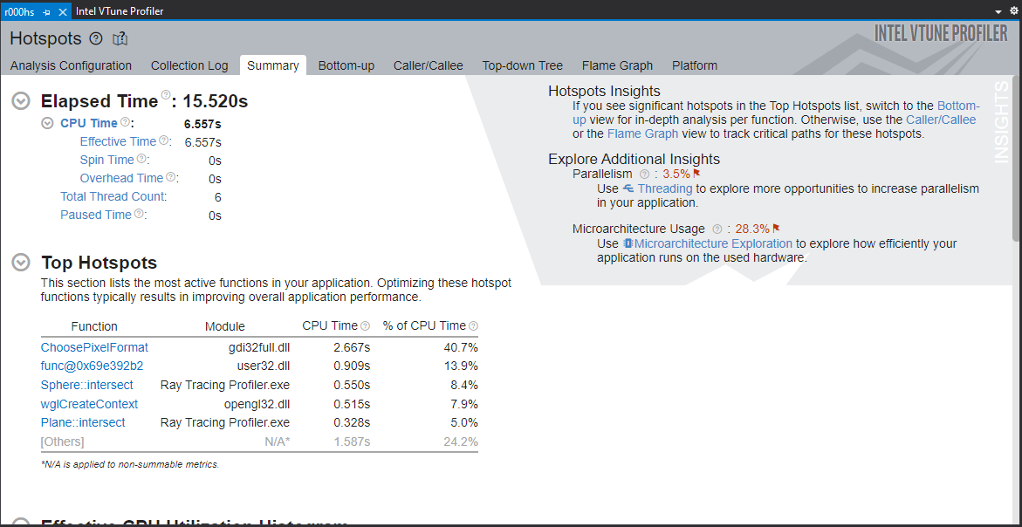

#### Reflection:

This was easy to do once I got VTune installed and found the performance profiler, it was in a different place than described in the video **Debug -> Performance Profiler.** I think I prefer the Microsoft profiler better, something about it is easier to read for me. Although intel definitely gives more information.

#### Metadata:

Profiling

#### Further information:

Which is better instrumentation or sampling?

Is the intel or Microsoft profiler better or is it a matter of personal preference?

Why do you not use the Microsoft instrumentation mode?

Why does the Microsoft instrumentation mode not work or is very slow?

## Week 8 – Lab H

Date: 22/11/2022

### Q1. BigString concatenators

#### Question:

Extend your BigString class to include the following new methods:

1. BigString& operator+= (const BigString& rhs);
2. BigString operator+ (const BigString& rhs) const;

#### Solution:

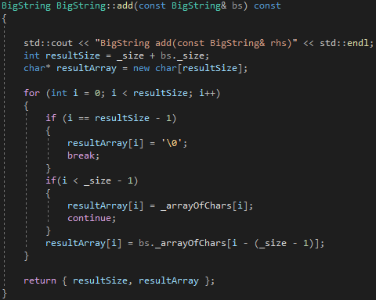

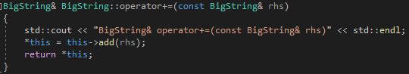

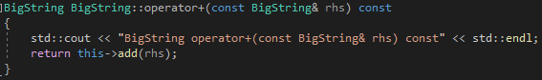

#### Test data:

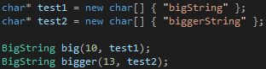

#### Sample output:

 = 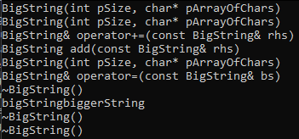

 = 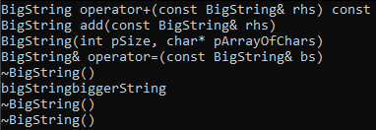

#### Reflection:

I couldn’t get the + operator to use += like I wanted while also sticking to the specified prototypes. I’m not sure if I am just not understanding something full or if its not possible will the given prototype.

#### Metadata:

Adding strings

#### Further information:

Am I not understanding something with the + operator?

### Q2. Test harness (BigString concatenators)

#### Question:

Extend your test hardness to include the new string concatenators, and test the two new methods. Consider ways to improve efficiency then implement and test the improved version.

#### Solution:

Addition benchmark



Inline solution

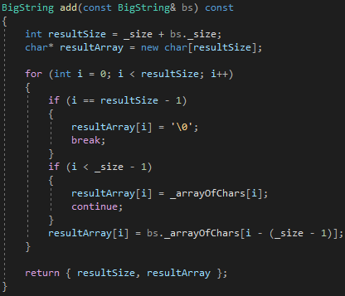

#### Test data:

n/a

#### Sample output:

Addition benchmark







**Average 3333.33 nanoseconds**

Inline solution







**Average 2900 nanoseconds**

#### Reflection:

The only possible improvement I could think of was to inline the add method. This caused a slight increase in speed but this was probably just lucky timings.

#### Metadata:

Improvement?

#### Further information:

What is the improvement that was expected here?

### Q3. BigString move constructor and operator

#### Question:

Extend your BigString class to include the following new methods:

1. BigString (const BigString&& rhs);
2. BigString& operator= (const BigString&& rhs);

#### Solution:

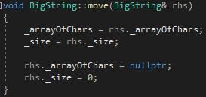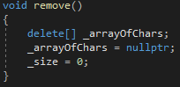

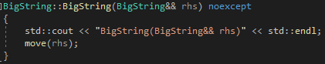

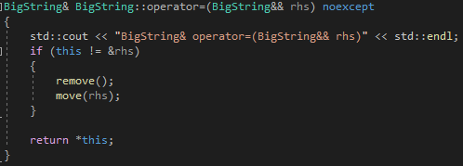

#### Test data:

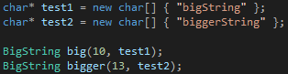

#### Sample output:

 = 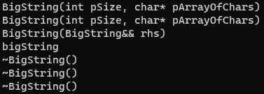

 = 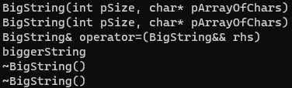

#### Reflection:

I think I understand moves I’m just not sure why or when you would need to use them.

#### Metadata:

Moves

#### Further information:

What are some use cases for moves?

### Q4. Test harness (BigString move constructor and operator)

#### Question:

Extend your test hardness to include the two new methods. Evaluate how much performance improvement you get using the move rather than classical functions.

#### Solution:

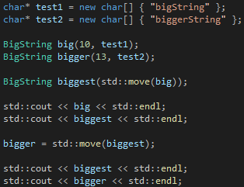

#### Test data:

n/a

#### Sample output:

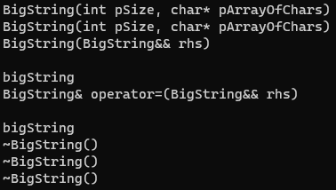

#### Reflection:

I had a misunderstanding of how to use move properly but now I understand that its should be used implicitly by the compiler when there is a temporary anonymous

#### Metadata:

Moves

#### Further information:

n/a